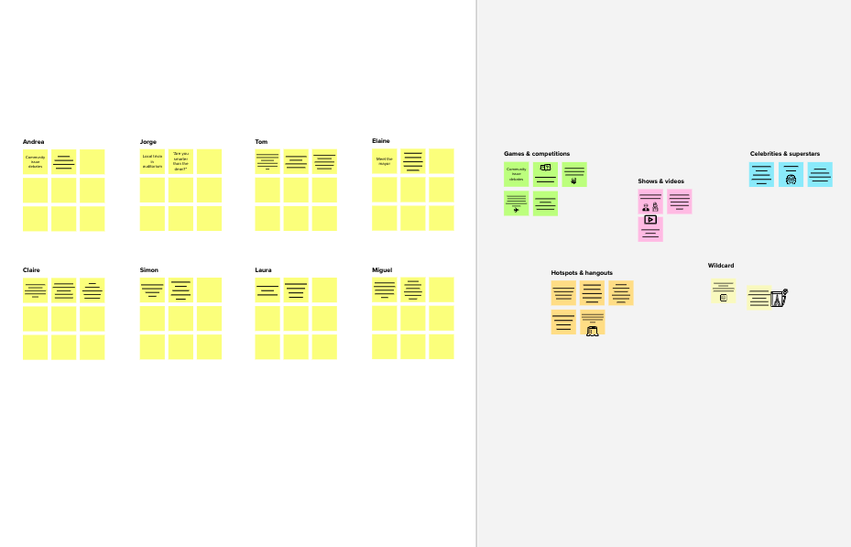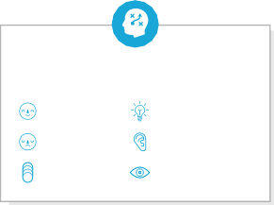

**TI**

Pa cu sti th co th

**Importance**

If each of these tasks could get done without any difficulty or cost, which would have the most positive impact?

**key** on the keyboard.

**H**

**P**

rticipants can use their rsors to point at where cky notes should go on e grid. The facilitator can nfirm the spot by using

e laser pointer holding the

**USING METHODS**

**USING VISUALS**

**USING TEMPERATURE**

**DINESH M**

**JEEVA S**

**VAITHESWARAN VC**

**NAVEENRAJAN M**

If possible, be visual.

Go for volume.

Listen to others.

Defer judgment.

Encourage wild ideas.

Stay in topic.

**Key rules of brainstorming**

To run an smooth and productive session

**C Learn how to use the facilitation tools**

Use the Facilitation Superpowers to run a happy and productive session.

[**Open article**](https://support.mural.co/en/articles/2113740-facilitation-superpowers)

**B Set the goal**

Think about the problem you'll be focusing on solving in the brainstorming session.

**A Team gathering**

Define who should participate in the session and send an invite. Share relevant information or pre-work ahead.

**10 minutes** to prepare

**1 hour** to collaborate

**2-8 people** recommended

[**Share template feedback**](https://muralco.typeform.com/to/CiqaHVat?typeform-source=app.mural.co)

**Keep moving forward**

**Strategy blueprint**

Define the components of a new idea or strategy.

[**Open the template**](https://app.mural.co/template/e95f612a-f72a-4772-bc48-545aaa04e0c9/984865a6-0a96-4472-a48d-47639307b3ca)

**Customer experience journey map**

Understand customer needs, motivations, and obstacles for an experience.

[**Open the template**](https://app.mural.co/template/b7114010-3a67-4d63-a51d-6f2cedc9633f/c1b465ab-57af-4624-8faf-ebb312edc0eb)

**Strengths, weaknesses, opportunities & threats**

Identify strengths, weaknesses, opportunities, and threats (SWOT) to develop a plan.

[**Open the template**](https://app.mural.co/template/6a062671-89ee-4b76-9409-2603d8b098be/ca270343-1d54-4952-9d8c-fbc303ffd0f2)

**Quick add-ons**

1. **Share the mural**

**Share a view link** to the mural with stakeholders to keep them in the loop about the outcomes of the session.

1. **Export the mural**

Export a copy of the mural as a PNG or PDF to attach to emails, include in slides, or save in your drive.

Detecting the fire light and smoke plumes emitted from the fires

Detects the forest fires using CO2

Detecting fire using Movement of birds

Detect the forest fires by temperature regularly monitoring

Collecting data using satellite image

Collecting data using drones flying over the forest

Forest officer can view the recommanable forest fire through SMS

Deep learning based Mathematical for detecting forest fire

Forest officer can view the recommanable forest fire through SMS

Deep learning based Mathematical for detecting forest fires

Collecting data using satellite image

Collecting data using drones flying over the forest

Detecting fire using movements of Birds

Detect the forest fire using CO2

Detect the forest fires by temperature regularly monitoring

Detecting the fire light and smoke plumes emitted from the fire

**TIP**

Add customizable tags to sticky notes to make it easier to find, browse, organize, and categorize important ideas as themes within your mural.

Detect the forest fires by temperatures regularly monitoring

Collecting data using drones flying over the forest

Fire fighting robots can now use sensors such as flame sensor to detect fires

Pre-trained model image processing

Fire detection using CNN modes

Detect the forest fire using CO2

Regularly remover dry leaves

Optical sensor and Digital cameras can be used

Monitoring the forest using satellite

Deep learning based Mathematical for detecting forest fires

Forest officer can view the recommanable forest fire through SMS

Detecting by the fire light and smoke plumes emitted from the fires

A UAV can detect forest fire due to high mobility in vehicles

IR sensors can be used to detect to the forest fire

Collecting data using satellite image

Detecting fire using movement of Birds

**PROBLEM**

**How might we prevent the forest fire by early detecting**

**methods?**

**Template**

|  |  |
| --- | --- |
|  |  |
|  |  |

**Brainstorm**

**& idea prioritization**

Use this template in your own brainstorming sessions so your team can unleash their imagination and start shaping concepts even if you're not sitting in the same room.

**Before you collaborate**

A little bit of preparation goes a long way with this session. Here’s what you need to do to get going.

**10 minutes**

**1**

**Define your problem statement**

What problem are you trying to solve? Frame your problem as a How Might We statement. This will be the focus of your brainstorm.

**5 minutes**

**2**

**Brainstorm**

Write down any ideas that come to mind that address your problem statement.

**10 minutes**

**TIP**

You can select a sticky note and hit the pencil [switch to sketch] icon to start drawing!

**3**

**Group ideas**

Take turns sharing your ideas while clustering similar or related notes as you go. Once all sticky notes have been grouped, give each cluster a sentence-like label. If a cluster is bigger than six sticky notes, try and see if you and break it up into smaller sub-groups.

**20 minutes**

**4**

**Prioritize**

Your team should all be on the same page about what's important moving forward. Place your ideas on this grid to determine which ideas are important and which are feasible.

**20 minutes**

**After you collaborate**

You can export the mural as an image or pdf to share with members of your company who might find it helpful.

[**Share template feedback**](https://muralco.typeform.com/to/CiqaHVat?typeform-source=app.mural.co)

**Feasibility**

Regardless of their importance, which tasks are more feasible than others? (Cost, time, effort, complexity, etc.)

**Need some inspiration?**

See a finished version of this template to kickstart your work.

[**Open example**](https://app.mural.co/template/e5a93b7b-49f2-48c9-afd7-a635d860eba6/93f1b98d-b2d2-4695-8e85-7e9c0d2fd9b9)